Current Flow Theory
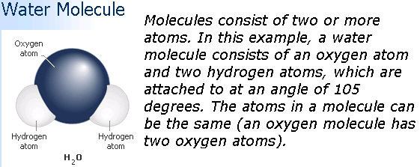
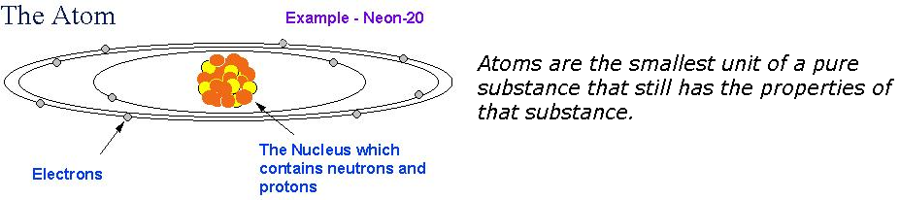
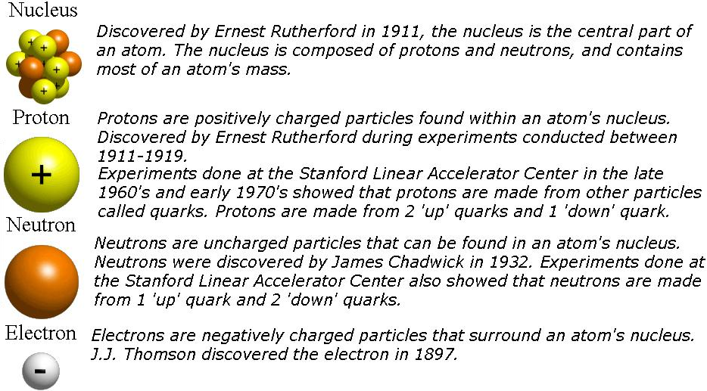
Electricity is the movement of electrons through a conductor. Electrons are negatively charged particles that move toward something that is positively charged. Electrons are attracted to protons. Electrical pressure or electromotive force causes a potential difference that attempts to push an electron out of the atoms orbit and toward the excess protons. If an electron is freed from an atoms orbit the atom acquires a positive charge because it now has one more proton than it has electrons. The unbalanced atom attempts to return to its balanced state so it will attract electrons from the orbit of other balanced atoms. This starts a chain reaction as one atom captures an electron and another atom releases an electron. As these actions continue to occur, electrons will flow through the conductor. A stream of free electrons form and an electrical current is started.

Conventional Theory

Conventional Theory states that current flows from positive to negative. The basic idea behind this theory is that although electrons move toward the protons, the energy force that is released as the electrons move begins at the point where the first electron moved to the most positive charge. As electrons continue to move in one direction, the released energy moves in the opposite direction. The conventional theory arbitrarily chose the direction of current flow to be from the positive terminal of the voltage source, through the external circuit, and then back to the negative terminal of the source. The conventional theory is the oldest theory and serves as the basis for most electrical diagrams and circuit operation of vehicle components.

Electron Theory

Electron Theory states that current flows from negative to positive. The discovery of the electron in 1897 led to the electron theory of current flow, which is from the negative terminal, through the external circuit, and then back to the positive terminal of the source- just the opposite of the conventional theory. The electron theory is also known as the scientific theory.

Hole-Flow Theory


Another theory has been developed to explain the mysteries of current flow. This theory is called the hole-flow theory and is actually based on both electron and conventional theory.

Which Theory?
Why all the confusion of current flow within a circuit? Remember that electricity travels through a conductor at over 186,000 miles per second. Even with the technology available today scientists are unable to prove these theories, with electricity traveling at the speed of light, it’s a little tough to isolate which direction current is going to and from. Fortunately, it really doesn’t matter as long as you know what current flow is and what affects it. From this understanding you will be able to figure out how the circuitry basically works, how to test it, and how to repair it.

